Planning Alert from Hertsmere
Members of the public have a month to comment on plans to create a 130-hectare solar farm near Aldenham.
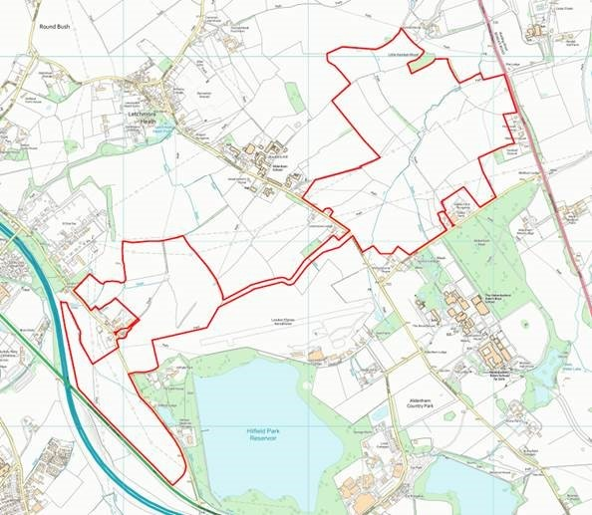

A planning application has been submitted by Elstree Green Limited seeking permission for the construction and operation for 35 years for a grid-connected solar photovoltaic farm with battery storage and other ancillary infrastructure on land north of Butterfly Lane and surrounding Hilfield Farm, and west of Hilfield Lane (map of the location is pictured above left and available on our website).
The application can be viewed by going to our website www.hertsmere.gov.uk/planningsearch and searching for either Butterfly Lane or reference number 21/0050/FULEI.
Councillor Linda Silver, Chairman of our Planning Committee, said: “I would urge anyone who lives, works or uses the area, particularly those who think they might be directly affected, to take the time to view the proposal and give us your thoughts.
“You can view and submit your comments on the plans, without leaving your home, if you have a computer or a smartphone.
“Our Civic Offices remain closed due to the coronavirus outbreak, so we would urge everyone to use our online services.”
Comments should be submitted before 24 February via our website or by e-mailing consult.planning@hertsmere.gov.uk and quoting the case reference number.

